GRAB AND GO
- CALL US ON 9988 3200 OR 9988 3111
- PLACE YOUR TAKEAWAY ORDER
- PAY BY CREDIT CARD OVER THE PHONE
- WE CAN DELIVER TO YOUR CAR AT THE TOP OF THE STAIRS!
PRE-MADE MEALS
- PRE-MADE FRESH MEALS THAT ARE READY TO COLLECT. SIMPLY RE-HEAT AT YOUR CONVENIENCE
- NO WAITING TIME TO PICK-UP!
- FIVE DIFFERENT OPTIONS DAILY
- AVAILABLE UNTIL SOLD OUT, GET IN QUICK!
PICK-UP TAKEAWAY DEALS
- COMPLIMENTARY TOILET ROLL WITH PICK-UP TAKEAWAY ORDERS
- ORDER 2 LARGE PIZZAS, GET A FREE GARDEN SALAD
- ORDER 3 LARGE PIZZAS, GET A FREE GARDEN SALAD AND GARLIC BREAD
- ORDER 2 PASTAS, GET A FREE GARLIC BREAD
- ORDER 3 PASTAS, GET A FREE GARDEN SALAD
HOME DELIVERY
- FROM 5PM – 8.30PM ON TUESDAY - SUNDAY
- CALL US ON 9988 3200 OR 9988 3111. PLACE YOUR ORDER AND PAY OVER THE PHONE
- $4 DELIVERY CHARGE, OR FREE DELIVERY FOR ORDERS OVER $40
DRINKS
- COFFEE AND HOT BEVERAGES AVAILABLE FOR TAKEAWAY
- COLD BEVERAGES AVAILABLE FOR TAKEWAY AND HOME DELIVERY
- IF YOU ORDER FOOD, A BOTTLE OF WINE OR A 6-PACK OF BEER/CIDER CAN BE PURCHASED FOR BOTH TAKEAWAY AND HOME DELIVERY
GIFT VOUCHERS
- $100 VOUCHERS FOR ONLY $75!
- $50 VOUCHERS FOR ONLY $40!
- CAN PURCHASE IN-STORE AND OVER THE PHONE FOR HOME DELIVERY
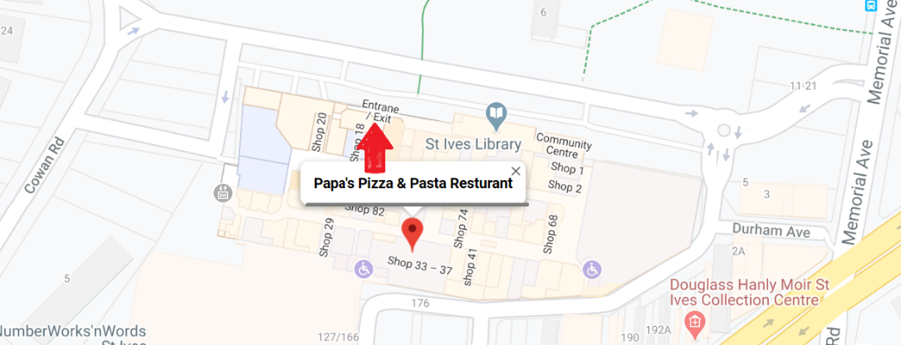
St Ives Shopping Village, Shop 17, 166 Mona Vale Road, St Ives, NSW 2075

